PHÒNG GD&ĐT BÌNH GIANG | ĐỀ KIỂM TRA GIỮA HỌC KỲ II  NĂM HỌC 2017 - 2018  MÔN: TIẾNG ANH - LỚP 6  Thời gian làm bài: 45’(Không kể thời gian giao đề)  (Mã đề 1.1: Dành cho HS học chương trình cũ)  (Đề bài gồm 04 trang)
  ĐỀ CHÍNH THỨC
Lưu ý: Học sinh làm bài vào tờ giấy thi, không làm bài vào đề thi này.
------------------------------------------------------------------------------------
A. LISTENING
I. Part 1. Listen to five short conversations twice and decide if the statements are True (T) or False (F). (1.0 pt)
(Nghe 5 đoạn hội thoại ngắn 2 lần và quyết định xem những câu sau là đúng (T) hay sai (F).)
1. The name of Nick’s dog is DAT.
2. The dog is five years old.
3. Nick lives in Old Street.
4. Nick is going to Green Park.
5. Nick is going there by car.
II. Part 2. Listen to five short conversations twice and choose the correct answer A, B or C for each question. (1.0 pt)
(Nghe đoạn 5 đoạn hội thoại ngắn 2 lần và chọn phương án đúng nhất trong số A, B hoặc C cho mỗi câu hỏi sau.)
1. What’s Tom playing?

A. playing basketball B. playing football C. watching TV
2. What’s Nick doing?
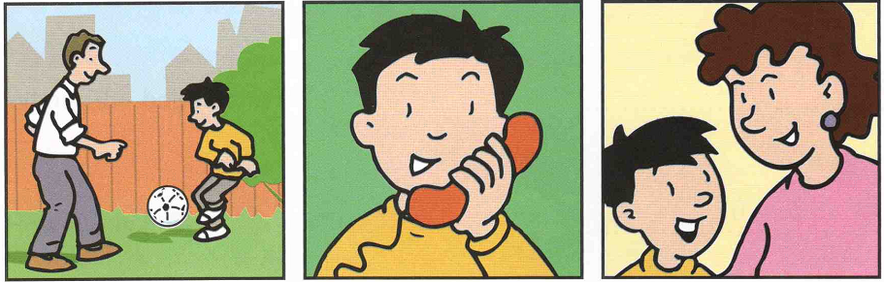
A. playing football B. phoning a friend C. talking to his mother
3. What’s Ben doing?
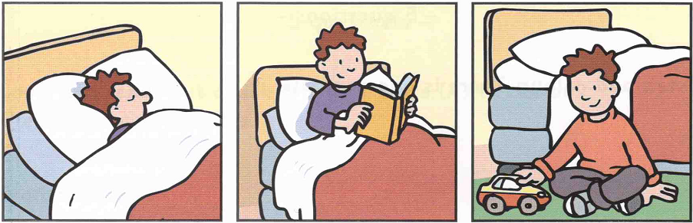
A. sleeping B. reading a book C. playing in the bedroom
4. What’s Kim doing?
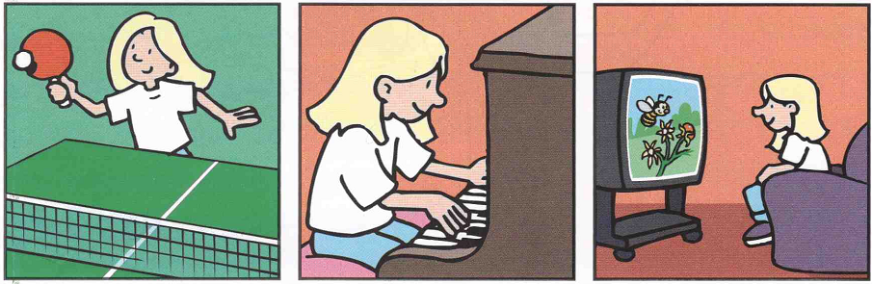
A. playing table tennis B. playing the piano C. watching TV
5. What’s Ann painting?

A. a picture of a book B. a picture of flowers C. a picture of a monster
B. VOCABULARY - GRAMMAR - LANGUAGE FUNCTION
I. Choose the best option marked A, B or C to complete each sentence. (2.0 pts)
(Chọn đáp án đúng nhất được đánh dấu A, B hoặc C để hoàn thành các câu dưới đây)
1. He is not tall. He is ___________.
A. light B. heavy C. short
2. Long: “What ______________ you like?” – Tuan: “I’d like some milk.”
A. would B. do C. are
3. Lan: “What color are his teeth?” – Tuoi: “They’re____________.”
A. green B. white C. red
4. People often feel ___________ when they want a hot drink.
A. hot B. cold C. full
5. Does she have ________________?
A. long black hair B. hair long black C. black long hair
6. Daisy: “How _________ is a bowl of noodles?” – Nhi: “It’s twenty-five thousand Dong.”
A. many B. often C. much
7. Tam: “What’s your favorite food?” – Minh: “I like ____________.”
A. a glass of milk B. some water C. fish
8. Tuyen: “How __________ are you going to stay in Ho Chi Minh city?” – Ba: “For 5 days”
A. long B. often C. much
9. Dang: “How often does Tuan go jogging?” - Hoang: “____________________.”
A. On foot B. Every day C. In the morning
10. Diu: “How much ____________ do you want?” - Hien: “Five____________, please.”
A. rice - kilo B. a rice - kilos C. rice - kilos
C. READING

I. Read and choose a sentence in column A which is suitable to the picture in column B. (1.5 pt)
(Đọc và chọn một câu ở cột A phù hợp với một bức tranh phù hợp ở cột B.)
Column A |  | Column B
1. They are at school.  2. They are going sailing.  3. They are playing basketball.  4. They are at the zoo.  5. They are at the store. | A | 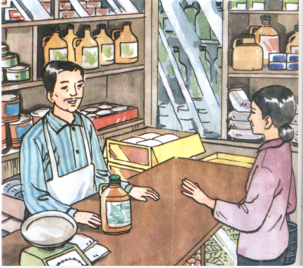
 | B | 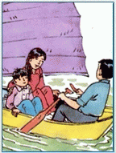
 | C | 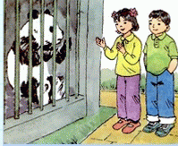
 | D | 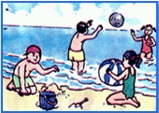
 | E | 
 | F | 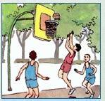

II. Read the passage carefully and choose the correct answer A, B or C for each question. (1.5 pt)
(Đọc kỹ đoạn văn rồi chọn câu trả lời đúng trong số A, B hoặc C cho mỗi câu hỏi)
Binh likes outdoor sports. He can play soccer, tennis and badminton. He enjoys swimming and jogging in the morning. He likes summer because he can go swimming every day. He doesn't like winter because it is very cold. He likes spring when there are a lot of flowers in the garden, but he thinks fall is the best season because the weather is fine and people can play any sports they like.
1. What sports can Binh play?
A. soccer, tennis and basketball
B. soccer, table tennis and volleyball
C. soccer, tennis and badminton
2. What does he like doing in the morning?
A. jogging and swimming
B. playing soccer and jogging
C. swimming and running
3. Why does he like summer?
A. Because he can go swimming every day.
B. Because he can go swimming in the evening.
C. Because he can play any sports he likes.
4. What season doesn’t he like?
A. fall B. winter C. spring
5. What season does he think the best?
A. spring B. summer C. fall
D. WRITING
I. Do as directed at the end of each sentence. (1.5 pt)
(Làm như được hướng dẫn ở cuối mỗi câu)
1. What/ you/ do/ do/ spring/ the/ in/ ?// (Rearrange the jumbled words to make a meaningful sentence = Sắp xếp lại các từ bị xáo trộn để tạo thành câu có nghĩa.)
2. often/ he/ afternoon/ the/ in/ flies a kite// (Rearrange the jumbled words to make a meaningful sentence = Sắp xếp lại các từ bị xáo trộn để tạo thành câu có nghĩa.)
3. cool/ she/ weather/ likes// (Rearrange the jumbled words to make a meaningful sentence = Sắp xếp lại các từ bị xáo trộn để tạo thành câu có nghĩa.)
4. How many students are there in your school? (Finish the sentence in such a way that it means the same as the sentence printed before it = Viết lại câu bắt đầu với từ cho sẵn sao cho nghĩa của nó tương tự như câu cho trước.)
=> How many students does _____________________________________________?
5. It’s half past nine. Finish the sentence in such a way that it means the same as the sentence printed before it = Viết lại câu bắt đầu với từ cho sẵn sao cho nghĩa của nó tương tự như câu cho trước.)
=> It’s nine ___________________________________________________________.
II. Use the words given to make a complete passage. (1.5 pt)
(Dùng các từ gợi ý để viết thành một đoạn văn hoàn chỉnh.)

Lan’s school/ be/ the city. It/ be/ Tran Hung Dao Street. It/ be/ big school. It/ have/ three floors/ twenty classrooms. Lan/ be/ grade six. Her classroom/ be/ the second floor. Lan/ go to school/ the morning. She/ have/ classes from seven to half past eleven.

===========The end ============

Họ tên học sinh:……………………………………Số báo danh:…………………..
Chữ kí giám thị 1: …………………… Chữ kí giám thị 2:……………….………….

