PHÒNG GD&ĐT BÌNH GIANG | ĐỀ KIỂM TRA GIỮA HỌC KỲ II  NĂM HỌC 2017 - 2018  MÔN: TIẾNG ANH - LỚP 7  Thời gian làm bài: 45’(Không kể thời gian giao đề)  (Mã đề 1.2: Dành cho học sinh học chương trình cũ)  (Đề bài gồm 04 trang)
  ĐỀ CHÍNH THỨC
Lưu ý: Học sinh làm bài vào tờ giấy thi, không làm bài vào đề thi này.

A. LISTENING
I. Part 1. Listen to five short conversations twice and decide if the statements are True (T) or False (F). (1.0 pt)
(Nghe 5 đoạn hội thoại ngắn hai lần và quyết định xem những câu sau là đúng (T) hay sai (F).)

1. Miss Riad is Nick’s teacher.

2. Nick’s class has 16 children.

3. There are four girls in Nick’s class.

4. Nick sits next to Tomy at school.

5. At school Nick plays with Bill.
II. Part 2. Listen to five short conversations twice and choose the correct answer A, B or C for each question. (1.0 pt)
(Nghe đoạn 5 đoạn hội thoại ngắn 2 lần và chọn phương án đúng trong số A, B hoặc C cho mỗi câu hỏi sau.)
1. What is Pat’s favourite animal?
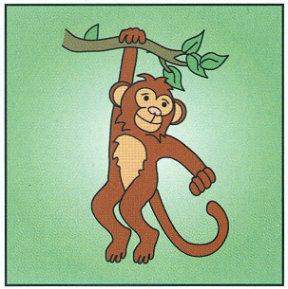
A. crocodile B. elephant C. monkey
2. What is Sue doing?
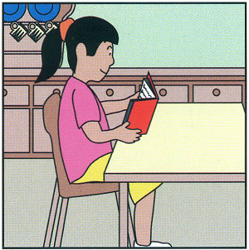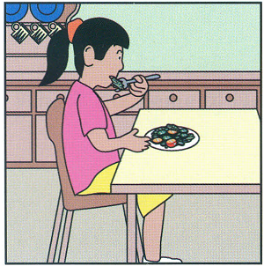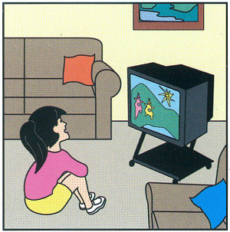
A. reading a book B. having her lunch C. watching TV
3. Which boy is Ben?
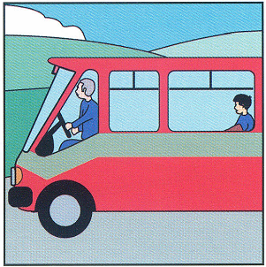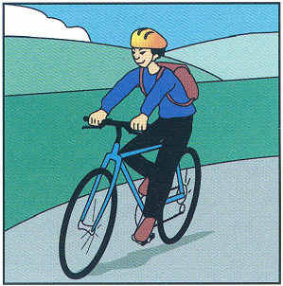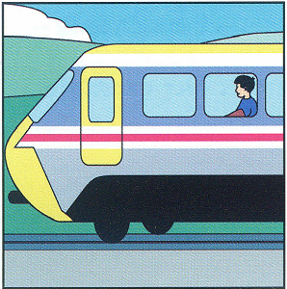
A. go to school by bus B. ride a bike to school C. go to school by train
4. What does May want for her birthday?
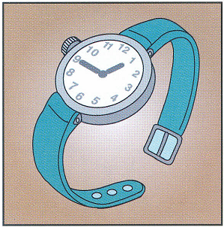
A. a camera B. a new watch C. a new doll
5. Which is Sam’s dad?

A. wear jeans and a T-shirt B. wear a black jacket C. wear jeans, a shirt and glasses
B. VOCABULARY - GRAMMAR - LANGUAGE FUNCTION
I. Choose the best answer to complete each sentence. (2.0 pts)
(Chọn đáp án đúng nhất để hoàn thành mỗi câu sau)
1. Hoa’s tooth hurts but my tooth _________.
A. didn’t B. isn’t C. doesn’t
2. Minh was very happy. His classmates were happy, _________.
A. too B. neither C. so
3. Are you busy on the___________ ?
A. Sunday B. weekend C. morning
4. ___________a little salt, sugar and vinegar to the mixture.
A. Slice B. Peel C. Add
5. You can buy some cucumbers at the ___________ stall.
A. food B. meat C. vegetable
6. She is a slow runner. She always runs ________________.
A. slow B. slowly C. A and B
7. Kien: “Can you give me some rice?” – Vy: “I’m sorry. I only have _____and I need it.”
A. lots of B. a little C. too much
8. Hoang: “I feel sick.” - Doctor: “What’s the_______________?”
A. wrong B. thing C. matter
9. Lam: “What ___________ you like to watch?” – Tiep: “A detective movie.”
A. would B. can C. should
10. Ba: “What do you usually do in the evening?” – Lien: “We _________.”
A. talk about our day B. do morning exercises C. have breakfast
C. READING
I. Read and choose a sentence in column A which is suitable to a notice/picture in column B. (1.5 pt)
(Đọc và chọn một câu ở cột A phù hợp với một thông báo/ bức tranh phù hợp ở cột B.)
Column A | Column B
1. They are playing chess.  2. They are having a medical check-up.  3. You can see a play or a movie here six nights a week.  4. They are buying some pork at the meat stall.  5. They are talking about Lan’s sickness. | A. | 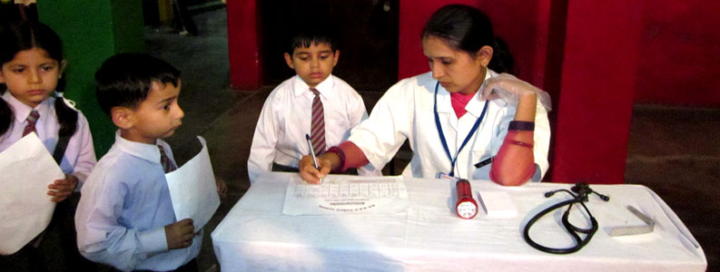
 | B. | 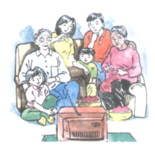
 | C. | WORKER’S THEATER  PLAYS AND MOVIES  8.PM. – EVERY NIGHT EXCEPT SUNDAY
 | D. | 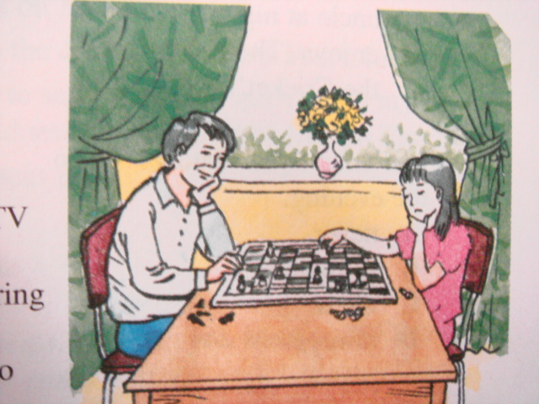
 | E. | 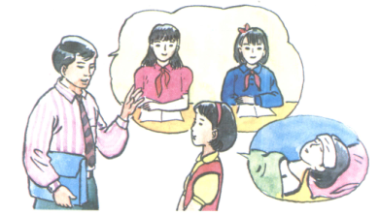
 | F. | 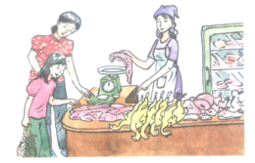
II. Read the passage carefully and choose the best answer A, B or C for each question. (1.5 pt) (Đọc kỹ đoạn văn và chọn đáp án đúng nhất A, B hay C cho mỗi câu hỏi sau.)
Summer is coming and schools in our city start improving water safety awareness for children. The aim of the program is to teach primary and secondary students about water safety. Followings are some of the advice every kid should clearly remember.
You should carefully listen to the pool lifeguards, play safely, stay away from the deep end and run or walk around the pool edge carefully.
You should always swim with an adult and between the red and yellow flags and and strictly obey all signs and lifeguards.
Being aware of the risks is the safe way to water play.
Questions:
1. What do schools in our city start doing?
A. helping children have better awareness of water safety
B. helping children swim better
C. talking about the importance of water
2. What is the aim of the program?
A. to teach primary and secondary students how to keep fit
B. to teach primary and secondary students about water safety
C. to give students advice on how to save water
3. How should students listen to the pool lifeguards?
A. carefully B. safely C. A and B
4. Who should students always swim with?
A. teachers B. pool lifeguards C. an adult
5. What is the safe way to play with water?
A. listening to friends B. having awareness of the risks C. A and B
D. WRITING
I. Finish each of the following sentences in such a way that it means the same as the sentence printed before it. (1.5 pt)
(Hoàn thành từng câu dưới đây sao cho nghĩa của nó tương đương với nghĩa của câu cho trước)
1. Let’s have some beef.
=> How about __________________________________________________________?
2. You shouldn’t eat too much fatty food.
=> You ought ___________________________________________________________.

3. Minh is a good swimmer.

=> Minh swims___________________________________________________________.

4. Song doesn’t like durian and Mai doesn’t either.

=> Song likes durian and ___________________________________________________ .

5. What is his weight?

=> How heavy __________________________________________________________ ?
II. Use the words given to make a complete passage. (1.5 pt)
(Dùng các từ cho sẵn để viết thành một đoạn văn hoàn chỉnh)
Yesterday, Hoa/ have/ a medical check-up./ First/ she/ fill in/ the medical record and wait/ the waiting room. After some minutes, the nurse/ call/ Hoa's name and take/ her/ the doctor's office. The doctor/ weigh/ Hoa and meansure/ her height. After that/ she/ take her temperature/ listen to her heart./ Everything/ be/ normal. Finally, Hoa/ leave/ the office./ She/ feel/ very happy.

===========The end ============

Họ tên học sinh:……………………………………Số báo danh:…………………..
Chữ kí giám thị 1: …………………… Chữ kí giám thị 2:……………….………….

